ECONOMICS 2004-05: SECTION 2: MICROECONOMICS STANDARD

2.1 Markets

2.1.1 Demand
- The demand curve shows the quantity of a good that consumers want at each price, assuming they have the effective purchasing power (income) to pay.
- The law of demand states that a higher quantity will be demanded at a lower price assuming other factors such as the price of substitutes are unchanged.
- Quantity demanded refers to a continuous flow of purchases per period of time.
- A single point on the demand curve reflects the quantity demanded at that price.

Movements Along the Demand Curve (Own Price Effect)
- Movements along the demand curve lead to changes in quantity demanded.
- Price and quantity demanded are negatively related:
- Demand is downward sloping: each increment in consumption leads to less and less satisfaction, and the consumer will buy more only for a lower price.
- As price rises, the quantity demanded of the good or service tends to fall
- It becomes an increasingly expensive way to satisfy the need or want associated with the good or service.
- People switch in part to some other goods or services to satisfy the same need, and less will be purchased of the good that has gone up in price.
- As the price of the good falls, it becomes relatively cheaper and more of it will be purchased and less of substitute goods.

Shifts in the Demand Curve (Income, Taste, Price of other goods, Advertising)
- The demand curve will shift out if more is demanded at each price and is caused by changes in factors other than the price of the good itself:
- Substitutes: if the price of coffee falls, many people will shift from drinking tea to drinking coffee and the demand curve for tea shifts in to the left.
- Complements: these are goods which tend to be used jointly.
- If the price of gasoline rises people are motivated to use their car less, and the demand for cars shifts to the left.

- Real income: when income rises, more people can afford to buy cars and the demand curve for cars shifts to the right for normal goods.
- Population: if the population grows there are more consumers and demand will shift out to the right.
- Tastes: more people may want the product or service and demand shifts out.
- Advertising: the more effective the advertising the greater the demand, unless the government uses negative advertising for things such as the dangers to health from cigarette smoking.
- Credit: more credit means it is easier to borrow for durable goods like cars and demand shifts right.

2.1.2 Supply

Movements along the supply curve
- The supply curve shows the quantity producers are willing to supply at each price.
- The Law of Supply states that higher quantities will be supplied at higher prices, all other things unchanged:
- This leads to a movement along the supply curve.
- As the extra cost of producing a unit increases, producers need a higher price to produce the product.

- Quantity supplied is a flow of goods or services per unit of time.

Shifts of the Supply Curve
- Changes in supply refer to shifts of the whole supply curve.
- The factors causing shifts in the supply curve include:
- Increase in number of producers in an industry: leads to an increase in supply.
- Prices of factors:
- If there are increases, less is supplied at each price (less profit is being made), and the supply curve shifts left.
- If factor prices fall, the supply curve shifts right.
- Technological changes: always lead to a rightward shift in supply.
- Weather: improvements can increase the supply of farm produce.
- Taxes and subsidies: increases in taxes lead to a fall in supply, increases in subsidies leads to an increase in supply.
- Changes in the prices of other goods:
- Sometimes goods are produced jointly such as wool and lamb’s meat: if the price of wool falls dramatically and farmers switch to producing something else, the price of lamb’s meat rises dramatically.
- Alternatively, if you could produce two goods from the same factory and the demand for one rises dramatically:
- Production will switch to that good and it’s supply will shift out.
- Production of the second good will fall and it’s supply will shift in.

2.1.3 Interaction of Demand and Supply

Markets
- A market is a meeting of buyers and sellers who do not have to physically meet.
- Markets cannot exist unless both buyer and sellers are involved.
- Markets include those for wheat, fruit, stocks and bonds and foreign exchange:
- Wheat produced in one place can be sold anywhere in the world.
- Between the London stock exchange, the New York stock exchange and the Tokyo exchange, it is now possible to trade certain stocks 24 hours a day: markets are not limited to certain intervals of time.
- Foreign exchange markets are located in the international telephone networks and computer hookups.
- In some rural markets, fruits, vegetables and fish may be quite expensive in the morning but be marked down drastically toward the end of the day, particularly if there is no refrigerated storage available.
- Non market sectors include non-governmental organizations (NGOs) such as charities and volunteer organizations which raise money from the public to pay for goods and services. The bulk of non market production is accounted for by govt. and NGOs: the money is provided by tax revenue and donations, and the non market goods and services are distributed to households and firms.

Market Equilibrium
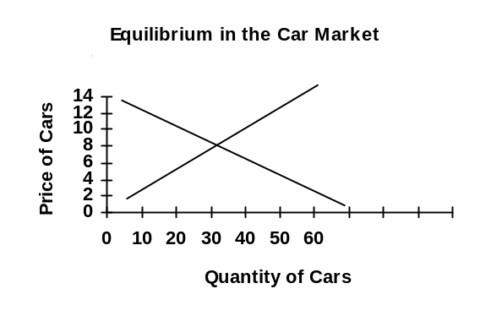
- Equilibrium occurs when quantity demanded equals quantity supplied.
- Only at a price of $8,000 does quantity demanded equal quantity supplied.
- Price below equilibrium: households will desire more but firms will not be prepared to offer as much leading to excess demand.
- Inventories will be falling, and sellers can charge a higher price.
- The price will edge back up to $8,000 where the quantity supplied and demanded will be equal to each other again.

- Price above equilibrium: people will want fewer cars while firms will be only too happy to supply more leading to excess supply:
- Inventories will be rising and firms will lower prices to clear the carlots.
- Households will be happy to buy cars at lower prices.

- No equilibrium: where supply is everywhere above demand, nothing will be produced because the higher price consumers are prepared to pay is less than the minimum price producers need to supply (spaceships).
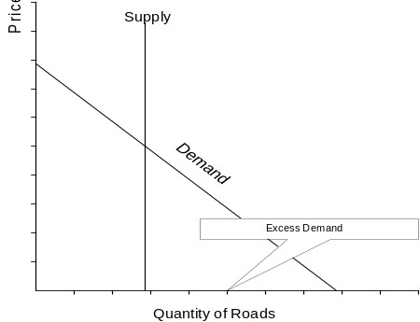
- Goods or services with no price:
- In most countries, roads are available free of charge and people will use them out to the point where demand intersects the horizontal axis leading to excess demand.
- Rationing does not take place: there is overcrowding.
- In some countries medicine is free and again there is excess demand which is likely to get worse as populations age.
- Rationing takes place through queueing (typically the govt. issues coupons to stop hoarding).

The Four Laws of Demand & Supply
- A rise in demand: excess demand, inventories fall, price and quantity increase:
- The rise in price acts as a rationing device to lower demand but encourages existing firms to produce more and for other firms to join the industry, thus moving resources into the industry to respond to the increase in demand.

- A fall in demand: excess supply, inventories rise, price and quantity decrease.
- A rise in supply: excess supply, inventories rise, price falls and quantity rises.
- A fall in supply: excess demand, inventories fall, price rises and quantity falls.

2.1.4 Price Controls

Price floor
- If price is held above equilibrium, there will be excess supply.
- Either inventories build up or the govt. purchases the surplus and stores it or sells it cheap on the international market.
- Minimum wage: the excess supply results in people not being able to find work, and the govt. supports the surplus by providing welfare support.
- Those who do find jobs are better off because their wages are higher than they would normally have been in a free market.

- Farmers who sell their crops at floor prices are better off, but the govt. traditionally purchases the surplus and stores it. If the crops are sold at a loss, it is taxpayers that pay the costs.
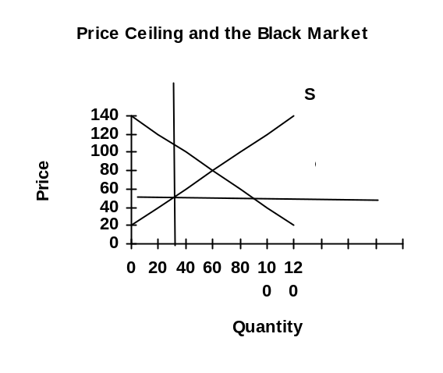

Price ceiling
- If price is held below equilibrium, there will be excess demand, shortages, and parallel or black markets often spring up.
- Black marketers buy at the low price and resell to the highest bidder ($100).
- The profit is represented by the difference between the two prices ($100 - $50) times the quantity they buy and resell.
- Black markets can exist because purchasers who have the money are willing to pay more than the ceiling price for the limited amounts of the good available.
- In centrally planned economies, black markets are illegal, and buyers have to wait for hours to get into stores, only to find that supplies are exhausted before they can be served.
- Govts. can ration the commodity by issuing only enough ration coupons to match the available supply and then distribute the coupons to purchasers who must present both the money and the coupons in order to get the goods.
- Rationing is often considered fairer than the black market.

Quantity controls: Quotas
- The govt. cannot force the quota to be above the equilibrium quantity, people cannot be forced to consume what they do not want.
- Thus quotas usually restrict the quantity below what would have been the case with a free market.

2.2 Elasticities
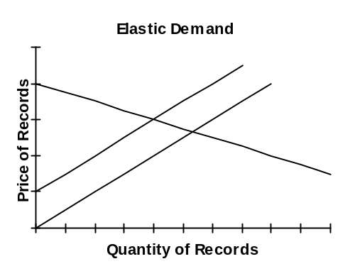

2.2.1 Price Elasticity Of Demand
- Elasticity measures the sensitivity of demand (quantity demanded) to changes in variables such as its own price.
- If the supply curve shifts because of govt. subsidies, it is useful to know the impact on the price and the quantity demanded.

Elasticity Formula
- Price elasticity of demand: measures responsiveness by dividing the percentage change in quantity demanded by the percentage change in price.
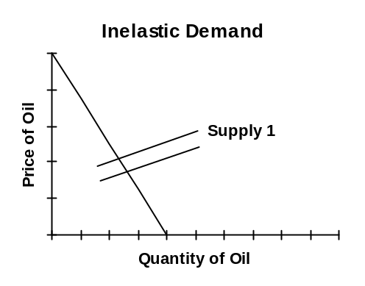
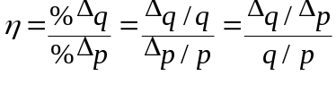
Where Δ means change in.

- The term on the top is the slope of the demand curve, while the term on the bottom is the slope of the ray from the origin to the point on the curve where you are measuring elasticity.
- As price and quantity demanded are inversely related the equation is always negative, but we tend to ignore the negative sign and report a whole number.

- Elastic demand (η > 1):
- A subsidy leads to an outward shift in supply, prices fall leading to a large increase in quantity demanded (%Δq > %Δp).
- If price fell by 10% and quantity demanded rose by 50%, the elasticity would be equal to 5, an unusually high number for elasticity
- Perfectly elastic (η = ∞): infinite change in quantity demanded (%Δq = ∞)

- Inelastic demand: (η < 1):
- A subsidy leads to an outward shift in supply, prices fall but there is only a small increase in quantity demanded (%Δq < %Δp)
- If price fell by 10% and quantity demanded rose by only 5%, elasticity is equal to 0.5.
- Perfectly inelastic (η = 0): no change in quantity demanded (%Δq = 0)

- Unit elastic demand (η = 1): if the responsiveness is about the same as the change in price, then the measure will be equal to (minus) one (%Δq = %Δp)...

Arc Elasticity
- Arc elasticity measures the elasticity over a segment of the curve.
- 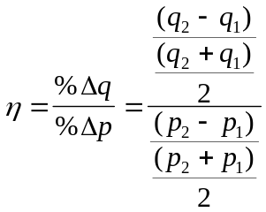The slope is taken from the the chord over that arc of the curve. As there are two points, the slope of the ray is determined by an average: the average quantity over the average price.

Point Elasticity
- Point elasticity measures the responsiveness of quantity to price at a particular point on the demand curve.
- The slope is given by the tangent to that point, and is often measured as dq/dp, which is determined by calculus.
- The slope of the ray is given by: q/p, the p and q corresponding to that point are used (rather than average p and q over an arc of the curve).
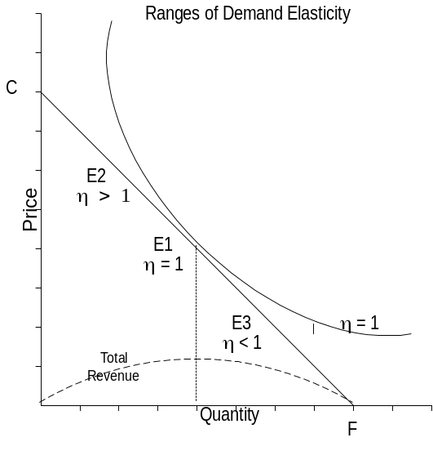

Elasticity Along a Straight Line
- Elasticity along a straight line demand curve varies from zero at the quantity axis to infinity at the price axis.
- In the figure:
- Below the midpoint of a straight line demand curve, E₃, elasticity is less than one and the firm wants to raise price to increase TR.
- Above the midpoint, E₂, elasticity is greater than one and the firm wants to lower price to increase TR.
- At the midpoint, E₁, elasticity is equal to one.

- For the straight demand curve, the ranges of elasticity are given by the formula:
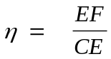
- For the curved demand curve, EF is the distance from the point where the tangent intersects the x axis to the tangency point divided by the distance from the tangency point to the intersection with the y axis.
- For a hyperbola, the point of tangency will always be the midpoint of a straight line and therefore, the elasticity is always equal to one along the curve.

- Where there are two straight line demand curves of the same slope, the one furthest from the origin is less elastic at each price than the closer one.
- Where two demand curves of different slopes intersect, the elasticities are different because the slopes are different at that point.

Factors Influencing Demand
- Substitutes: if there are many substitutes available, consumers can easily switch to other goods if prices rise.
- Time: it may be difficult to find substitutes in the short run so demand is likely to be less elastic in the short run than in the long run.
- Demand within product groups tends to be fairly elastic:
- The demand for gas versus electricity or gas versus diesel is fairly elastic.
- However, for energy as a whole, demand tends to be very inelastic because there are no substitutes for hydrocarbons.

- Size of item in budget: if consumers spend only a small amount on the item (such as matches for lighting candles) relative to their budget, it is likely to be inelastic: not sensitive to price changes
- Addiction: some goods are habit forming and tend to be price inelastic: coffee.

2.2.2 Cross Elasticity of Demand
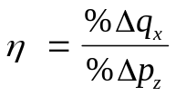
- Responsiveness of demand to changes in prices of other goods:

- Complementary goods:
- Quantity demanded increases when the price of the complement falls.
- If the price of gas fell to 10 cents a litre, sales of cars would increase.

- Substitute goods:
- Quantity demanded of one good falls when the price of the substitute falls.
- If the price of coffee rises, people tend to consume less coffee and more tea.

- Price cross elasticity tells us the relationship amongst goods:
- Bottle makers find they are in competition with producers of cans

2.2.3 Income Elasticity of Demand
- Income elasticity measures the percentage change in quantity demanded as income changes. 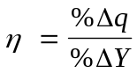
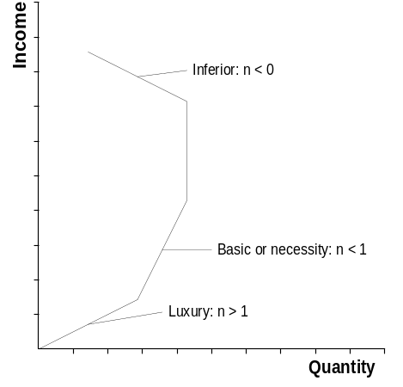
- Normal goods: an increase in income leads to an increase in consumption, demand shifts to the right.
- For basic or necessity goods, 0 < η < 1, quantity demanded will not increase much as income increases (income elasticity for food = 0.2)
- For luxury goods, η > 1, quantity demanded rises faster than income. For restaurant meals income elasticity is higher than for food, because of the additional restaurant service.

- Inferior goods: income elasticity is actually negative, the demand curve shifts left as income rises. As income rises, the proportion spent on food tends to fall while the proportion spent on services tends to rise.
- As economies grow, income elasticity helps determine what should be produced: firms will want to avoid producing inferior goods.
- Countries are at various stages of economic development and so have widely different income elasticities for the same products. As overseas incomes grow it may create new markets as demand shifts from inferior to normal goods.

2.2.4 Price Elasticity of Supply
- Elasticity of supply measures the responsiveness of the quantity supplied to changes in price:
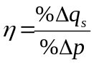
- Elasticity = 0: if the supply curve is vertical, and there is no response to prices.
- Elasticity = ∞: if the supply curve is horizontal, .
- Any straight line supply curve intersecting:
- The origin has an elasticity of one: at every point along the curve, the slope of the ray (q/p) equals the slope of the line (Δq/Δp).
- The price axis is elastic.
- The quantity axis is inelastic.

Determinants of Supply Elasticity
- If costs rise only slowly as production increases, a rise in price will stimulate a large increase in quantity supplied.
- If costs of production rise rapidly as output rises, then the stimulus to production which comes from rising prices will quickly be choked off.

Capacity:
- Ease of entry: the fewer the barriers to entry, the easier for firms to enter the industry to increase supply in response to an increase in price and supply is elastic.
- Factor mobility: the easier it is to move resources into the industry, the more elastic the supply curve.
- Ease of switching: if land and labour can be shifted easily from growing one crop to another, the supply will be more elastic:
- Even if it is possible to shift inputs, if the cost of inputs rises production costs will rise rapidly as output rises and supply will be inelastic.

- Spare capacity: if there is unused capacity, it is easy to increase production if demand should start to shift out.
- Ease of storing output: if it is easy to store production, the more elastic supply response to increases in demand.

Length of time:
- Length of production period: the more quickly the good can be made, the easier to respond to an increase in price.
- Time period: over time the firm can train labour and invest in more capital equipment and supply is more elastic in its response to price increases.
- Over the longer term as cheaper inputs are substituted and new production methods incorporated into the firm, outputs will tend to increase and prices will tend to moderate.

2.2.5 Applications of concepts of elasticity

PED and the firm
- Total Revenue: is equal to P*Q.
- By estimating the effect of a price change, firms can plan the number of goods to produce and estimate their potential revenue.
- Inelastic demand: price and total revenue are positively related
- If firms cut prices by 10% but sales only increase by 5%, revenues fall
- A rise in price will not only increase revenue but will also increase profit as costs will fall because less is produced.
- The increase in the number demanded is too small to offset the drop in the price of each good sold.
- Example: the oil industry where demand is inelastic, as prices rise, quantity demanded does not fall very much.

- Elastic demand: price and total revenue are negatively related
- If demand is elastic, a fall in price will increase revenue but not necessarily increase profit as production must increase quantity demanded increases.
- If quantity demanded increased 50% when price fell by 10%, revenues increase.
- The increase in the number demanded is more than enough to offset the fall in the price of each good sold.

- Unit elastic demand:
- Total revenue is constant regardless of changes in prices.
- The cut in prices is exactly offset by the increase in the quantity demanded, and total revenue to producers will stay the same.

Cross Elasticity
- Firms can determine the impact on sales and revenues of price changes by rivals, or when they or another industry changes the price of complements.
- During the oil crisis in the 1970s prices rose 400% in the space of three months but quantity demanded fell by less than 5% the first year.
- More energy efficient cars were bought by consumers
- Companies switched to using coal instead of oil in their furnaces.

- In the longer term, new supplies of oil were found, and the real price of oil declined as consumers switched to substitutes.
- For goods like energy it takes time to use up the stock of appliances and machinery and switch to those using energy in a more efficient manner.

Income Elasticity
- As economies grow:
- Firms will plan on producing fewer inferior goods.
- Production and purchasing of capital goods and other factors can be planned.
- Production for exports can be planned as new markets open and close.

2.4 Market Failure

Community Surplus
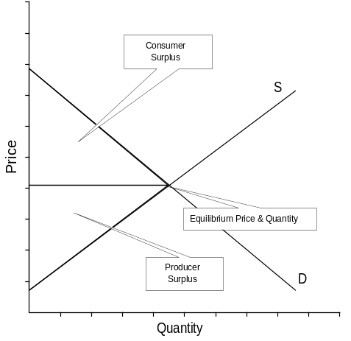
- Consumer surplus: the difference between what the consumer is willing to pay and what they actually pay in the market.
- Producer surplus: the difference between the price producers are willing to produce and the price they actually receive in the market.
- Community surplus is the sum of producer and consumer surplus.
- In perfect competition the market equilibrating mechanism will bring about a solution that maximizes community surplus.

2.4.1 Reasons for Market Failure
Externalities:
- Negative if social costs are greater than private costs and the market leads to overproduction:
- Private producers may take excessive social risks if they do not suffer the consequences of pollution.
- Common property problem: over crowding on highways, in cities and on fishing grounds: people keep entering as long as the value they receive exceeds operating costs, but it takes away from the value for others.

- Positive if social benefits are greater than private benefits and the market tends to underproduce.

Public, merit and demerit goods
- Goods and services are:
- Rivalrous or diminishable: if the use of a good by one person prevents use by another.
- Excludable: if people cannot use the good unless they pay for it.

- Pure public goods are both non-rivalrous and non-excludable, some people will be able to enjoy the benefits of the public good without paying a share of its cost (free rider problem).
- Govt. tends to provide the good and service and attempts to impose inefficient systems of charging such as tolls or entry fees.

- Merit goods: a private good with positive externalities and underproduced.
- Govt. can subsidize production or use advertising to increase demand.

- Demerit goods: rivalrous, excludable private goods with negative externalities. They tend to be overproduced.
- They could be banned, or negative advertising used to discourage use or be taxed heavily.

Abuse of Monopoly power
- By raising prices and lowering output, firms can increase producer surplus at the expense of consumer surplus.

The Information Problem
- Information is like a public good and is likely to be under produced in the private sector as the producer of information cannot exclude free riders,
- For example: the govt. enforces safety and health standards:
- Employers do not supply employees with the correct information about the dangers and hazards of the workplace,
- Producers do not publish accident histories for their products,

- Standards are often set by engineers with no incentives for economizing on costs while providing greater safety. Efficiency requires standards be expressed in terms of some level of performance rather than mandated design and materials,

- Moral hazard:
- People will not clear snow from their sidewalk because private cost exceeds private benefit if they are insured.
- Experts: if they benefit from lying, they may do so to get the business
- Insurance applicants: low risk will tend to underinsure (adverse selection)
- Govt. will make it mandatory: medical care to reduce adverse selection.

Factor Mobility
- It is assumed in perfect competition that factors are free to move to the market which offers the highest return. Because of such things as owning houses and being raised in a community with family and friends, it is not always easy for workers to move to the job with the highest salary.
- Market failure arises from:
- Lack of information: perhaps workers who lose a job in one region may not be aware of job possibilities in other regions.
- Even if they are aware, unemployed workers may not have the skills required to move to a new job.
- Even if they have the skills, those skills may be for an industry that is in decline throughout the country.

2.4.2 Possible Government Responses
- Charities and volunteer organizations can provide services, and insurance companies can provide some protection against adverse results.
- There is still a need for govt. intervention: Govt. can shift supply out by subsidizing producers or providing the good or service free.
- Non-market:
- Public provision of goods and services: schools, parks, health care,
- Regulations: against illegal drugs, for pollution, of public monopolies.
- Regulation: maximum emission levels can be set.
- Market:
- Subsidies to firms or transfer payments to individuals
- Taxes and fines: the tax is equal to the value of the gap between marginal social and private costs: MSC = MPC + externality tax.
- Property rights: people are given rights to pollution free air, countries in Africa can give property right over ‘big game’ animals to local villages.

Problems With Govt. Intervention:
- If a govt. prevents a market from allocating resources according to supply and demand, it must substitute a non-market system to allocate resources. Common ways include queueing, rationing through the use of coupons, and subsidizing. Problems arise:
- Parallel or black markets may develop.
- Monitoring and enforcement are expensive,

- There may be govt. failure:
- Internal costs: civil service is expensive, rigidity within govt. can slow down adaptation to more efficient ways,
- External costs: red tape imposed on businesses: higher safety standards, reporting, contesting regulations: the level of control may be unnecessarily high, the most expensive method may be specified,
- Future generations may not be taken into account,

- Govt. are not subject to the discipline of the market:
- Cities or publicly owned corporations often pollute more than private firms.
- Regulations lead to waste and do not adapt rapidly to changing market conditions.

- Private groups may lobby or bribe:
- Producers may influence regulators to protect them from market competition,
- Self regulation of physicians is seen as an attempt to maximize income rather than safeguard the public

- Where externalities cannot be internalized or people need to be protected from the negative consequences of their actions, govt. will need to regulate.

Legislation: Rent Controls
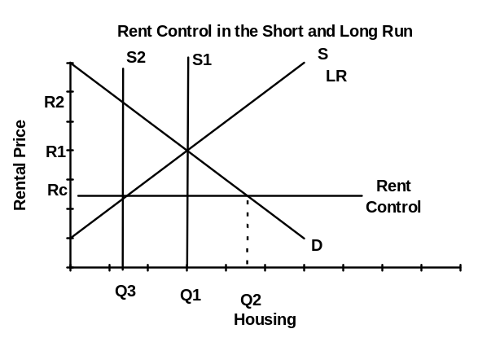
- In the short run: there will be excess demand equal to the distance between the vertical short run supply and the quantity demanded at the new lower price (Q2 - Q1).

- In the long run:
- Rates of return in the industry fall,
- Entrepreneurs transform apartments into office buildings or owned housing and sell the units,
- The supply of housing shifts left (S2), and intersects the long run supply where the rent ceiling is set (Q3)

- Excess demand for housing widens to the distance between long run supply and demand at the rent ceiling (Q2 - Q3)
- A black market appears: landlords will charge large deposits and entry fees,
- Govt. will protect existing tenants through special laws, and landlords will let buildings deteriorate as the rate of return is below the market rate.

- Rates of return may continue to fall, and landlords will charge black market prices to make up the difference,
- As tenants leave, buildings are pulled down and replaced with offices or housing to be sold,
- As the supply falls in the long run, an acute housing shortage appears (Q2 - Q3).

Government Failure
- Rents can be controlled quite successfully for a short period of time when there is an unexpected influx of people into a city.
- Rent controls transfer real income from landlords to existing tenants, and create severe housing shortages in the long run which leads to government failure.
- In the short run:
- The existing tenants gain because they pay a lower rent
- Existing tenants may lose if they are evicted and the building pulled down,
- Potential tenants lose as there is no housing at the lower rents,
- Landlords lose as they do not earn the opportunity cost rate of return (OCRR).

- In the long run:
- Existing tenants lose as they lose their rental accommodation (Q1 – Q3)
- Existing tenants must pay the black market price or they lose their apartment
- Even with tenant laws preventing eviction, tenants lose as buildings are allowed to deteriorate,
- Potential tenants lose as rental housing is eliminated and in very short supply.

To Correct Govt. Failure: Rent Controls Are Removed:
- Rents rise to the point where the short run vertical supply meets the demand curve (R2)
- The new higher rates of return attract construction of rental units, and the supply curve shifts to the right (S1),
- Supply will stop shifting right when it intersects demand at the point where long run supply is equal to demand at the old equilibrium rent (R1, Q1).

To Correct Market Failure: Public Housing or Subsidies for Landlords
- To correct the market failure which arises from a shortage of housing, the government builds public housing:
- The short run supply curve shifts out to the right and the ceiling price becomes the new equilibrium price.
- The extra cost of building houses will now be paid for by taxpayers.

- Landlords can be subsidized and the long run supply curve shifts out:
- Now it is cheaper for landlords to construct housing and supply will shift out to the ceiling price making it the new equilibrium price.
- Taxpayers now pay for the subsidy which will amount to the same as that with public housing.

Subsidies: Agricultural Policies
- Farm incomes tend to be very unstable and generally declining:
- Problems with the demand for farm output: income elasticity is close to zero for food, so there is very little potential for growth in demand.
- Problems with the Supply of farm products: growth in productivity is high for national security and balanced sectoral growth reasons, govt. provides:
- Finance for research and development plus farm extension systems,
- Subsidies for farm machinery, chemicals and irrigation.

- Widely fluctuating prices:
- The uncertainties of the weather mean that supplies of certain goods can be too little or too much leading to wide swings in price,
- Because food is a necessity, farmers face inelastic domestic demand: when there is a bumper harvest, prices and total revenue fall,
- Farmers in smaller countries face very elastic international demand:
- A bumper harvest can increase total revenue quite sharply,
- A bumper harvest in another competing country can lead to a drop in demand, leading to a sharp reduction in price and total revenue.

- Small changes in output can lead to large changes in price because both supply and demand are inelastic in the short run.

Govt. Tries to Stabilize Farm Incomes
- Short term: to shield farmers from fluctuations due to weather and crop failure.
- Long run: so that farm income grows at the same rate as for urban dwellers to ensure balanced sectoral growth. Govt. attempts to stabilize incomes by:

Buffer stocks policy: prices are fixed at Pf:
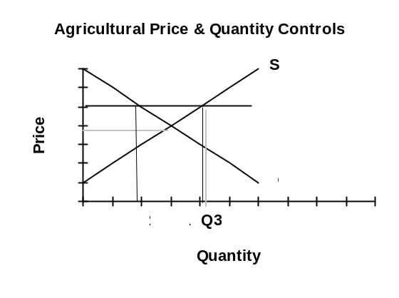
- When there is excess supply the govt buys up the surplus.
- If there is excess demand the govt. sells its stock to reduce the shortage.
- This system requires the govt. to provide storage facilities and pay the interest charges on the inventories being stored.
- Consumers are unhappy as they pay more (Pf), and consume less (Q1 - Q2)
- Farmers are happy as their revenue rises from Q1*P1 to Q3*Pf,
- Taxpayers are unhappy as they have to pay the revenue ((Q3 - Q2)*Pf).

- Enforced savings program: if the govt. cannot afford storage facilities:
- Farmers may be required to store crops.
- In years when farm incomes are high, the govt. will tax farmers and put the money into a savings account.
- When revenues fall, farmers are permitted to withdraw their savings.

- Providing unit elastic demand:
- If crops fail, total revenue stays the same (govt. taxes the surplus),
- If there is a bumper crop, total revenue stays the same as the govt. pays back the surplus from the previous year.

- Guaranteed price policy: to avoid storing crops, the govt. pays a subsidy to the farmer and allows the market to clear at the equilibrium price.
- Set Aside policy: used by the US, the government pays farmers for producing crops which they are not allowed to grow. This avoids excess supply and potential storage.
- The EU has started using this program as well.
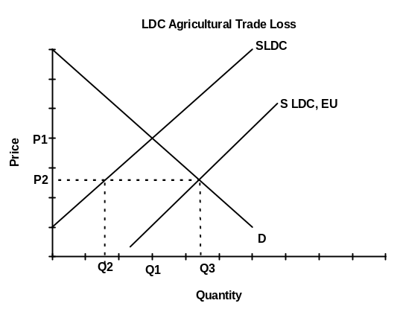
- European Common Agricultural Policy: imposes taxes on imports and offers a buffer stock system to EU farmers.

Potential Impacts on LDCs
- Govt. may choose to sell the surplus on international markets:
- Primary markets tend to be dominated by DCs, who are used to receiving a revenue of Q1*P1,
- When the govt. of industrialized countries sell their surplus, the supply curve shifts out (SLDC, EU), and they gain revenue (Q3 - Q2)*P2, taxpayers do not lose as much,
- But DCs lose revenue: (Q1*P1) - (Q2*P2)

- Under the latest EU system:
- Farmers will receive a subsidy depending on acreage under cultivation.
- They will no longer receive a subsidy which depends on production:
- Farmers no longer have an incentive to overproduce
- The EU does not have to buy and store excess supplies
- The EU is not motivated to flood international markets with the surplus and depress prices for LDCs.

Quota Programs
- If govt. choose to use quotas (Q2): there is no need to purchase excess supply, so taxpayers do not need to subsidize, and DCs do not lose revenue,
- Consumers are unhappy as they consume less but pay more,
- Farmers are happy as they earn a higher revenue on smaller production, and receive a quota right equal to 1/(market rate of interest) times the annual increase in revenue due to the quota system, the extra profitability is embodied in the price of the quota,
- New farmers are unhappy: they are forced to pay for the value of the quota and are forced to borrow from the bank. Typically, the annual payments absorb the extra income from the quota
- Thus the extra costs of the quota are gained by old farmers when they sell, but new farmers are no better off than old farmers were without the quota.

Taxes & Tradable Permits: Environmental Regulation
- Pollution is a negative externality which can arise from production or consumption. Private costs do not include the externalities, and too much of the product or service is produced.

Solutions
- Internalizing costs: by making the firm bear the full social costs, the pollution will be eliminated or reduced to socially acceptable levels.
- Pollution abatement benefits: these are often difficult to measure:
- If people think they will be paid compensation, they will claim the pollution is bad,
- If people think their taxes will be raised to pay for cleaning up the pollution, they will claim it is not so bad,
- The first levels of abatement are the most noticeable, eventually extra abatement appears to provide less and less value.
- Abatement is a public good and it is hard to charge free riders.

- Pollution abatement costs: tend to rise in an exponential pattern:
- It is hard to get firms to reveal the true costs,
- Costs rise slowly at first, but as more of the pollution is abated, what is left is more dispersed and much more expensive to eliminate,
- Zero pollution abatement is often not economically feasible
- Abatement techniques may be less than perfect,
- There may be legal and technical constraints on achieving optimal levels (where MB = MC).
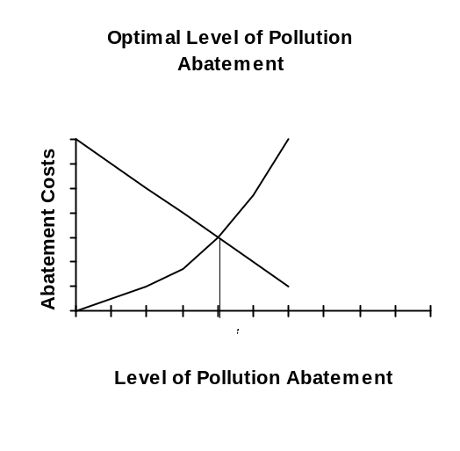

Direct controls
- If emission standards are set they are not efficient:
- All are forced to cut back the same amount, when low cost firms should be cutting back more
- Regulatory boards are not motivated to be efficient in the choice of technique
- Monitoring and enforcing are expensive
- Fines and penalties are often too lenient.

Emission Taxes
- Tax revenue is equal to tax times (Q* - Q1), where Q* is the optimal level of abatement determined from MC = MB, and Q1 is the level the firm can afford to abate to:
- As long as MC is below the tax, it is worth abating pollution
- Once MC is greater than the tax, it is worth just paying the tax.
- Polluters are left to find the most efficient way to abate,
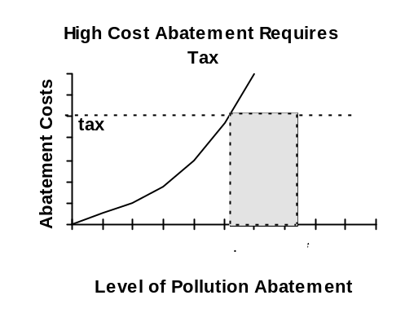
- Firms with high costs of abatement will not be able to afford to abate as much as the low cost firms,
- Monitoring and enforcement are still expensive,
- There is still guess work in setting Q*.

Tradable Emission Permits:
- Standards are set and each firm is issued with a permit to pollute up to Q* (they must abate back to Q* and can pollute to the right).
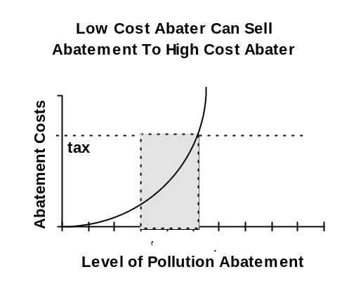
- Firms are permitted to trade emission permits.
- Low cost firms abate beyond Q* and sell the abatement to a high cost firm.
- High cost firms will abate up to Q1, then buy abatement up to Q*
- Presumably what they pay will be less than what they could be charged in tax.

- There are still problems in setting Q* and in monitoring and enforcement,
- Alternatively govt. could auction off the rights to pollute rather than giving them away:
- The govt. then earns the revenue from selling pollution rights. The problem is that they typically do not use the money to abate the pollution.
- The rights to pollute can be reduced each year to lower the level of pollution.

- Firms object to paying for the rights to pollute, but the payment simply reflects the fact that more efficient abaters are rewarded for having lower costs,
- The public objects to giving out rights to pollute:
- Experience has shown that self interest is the most efficient and effective way to deal with environmental damage,
- More abatement takes place by letting lower cost producers do it.

- Future generations are still not being taken into account:
- Govts. have difficulty getting the correct tradeoff between current and future generations: the future has no voting power today, plus govts. are only interested in projects which will benefit them in the next election.

